


Higher Nationals in Computing

Unit 30: Application Development
ASSIGNMENT 2

Learner’s name: Huynh Cam Hung
ID: GCS18026
Class: GCS0701A
Subject code: 1670
Assessor name: LE NGOC THANH

Assignment due: 10 May 2020 Assignment submitted: 10 May 2020
ASSIGNMENT 2 FRONT SHEET
Qualification | BTEC HND Diploma in Computing and Systems Development
Unit number and title | Unit 30: Application Development
Assignment due | 10 May 2020 | Assignment submitted | 10 May 2020
Learner’s name | Huynh Cam Hung | Assessor name | Le Ngoc Thanh

Learner declaration:
I certify that the work submitted for this assignment is my own and research sources are fully acknowledged.
Learner signature |  | Date

Grading grid
P3 | P4 | P5 | M3 | M4 | D3 | D4

Assignment title | Assignment 2: Application Implementation and Evaluation
In this assignment, you will have opportunities to provide evidence against the following criteria.
Indicate the page numbers where the evidence can be found.

Assessment criteria | Expected evidence | Task | Assessor’s Feedback
LO3: Work individually and as part of a team to plan and produce a functional business application with support documentation

P4 Create a formal questionnaire that effectively reviews your business application, problem definition statement, proposed solution and development strategy. Use this questionnaire as part of a peer-review and document any feedback given. | - Questionnaires to peer-review your application | 1
P5 Develop a functional business application based on a specified business problem | - A runnable implementation of the application
LO4: Evaluate the performance of a business application against its Software Design Document and initial requirements
P4. Review the performance of your business application against the Problem Definition Statement and initial requirements. | 3. Test plan  4. Test results | 3

Assessment criteria |  | Expected Evidence | Feedback  (note on Merit/Distinction if applicable)
Merit descriptor No. (M3)
Merit descriptor No. (M4)
Merit descriptor No. (M5)
Distinction descriptor No. (D2)
Distinction descriptor No. (D3)
Summative feedback

Assessor’s Signature |  |  |  | Date

Unit Number and Title | 30: Application Development
Academic Year | 2018
Unit Tutor | To Hoai Viet
Assignment Title | Assignment 2: Application Implementation and Evaluation
Issue Date
Submission Date | 10 May 2020
IV Name & Date

Learning Outcomes and Assessment Criteria
Pass | Merit | Distinction
LO3 Work individually and as part of a team to plan and produce a functional business application with support documentation |  | D2 Evaluate any new insights, ideas or potential improvements to your system and justify the reasons why you have chosen to include (or not to include) them as part of this business application.
P4 Create a formal questionnaire that effectively reviews your business application, problem definition statement, proposed solution and development strategy. Use this questionnaire as part of a peer-review and document any feedback given.  P5 Develop a functional business application based on a specified business problem. | M3 Interpret your peer-review feedback and identify opportunities not previously considered.  M4 Develop a functional business application based on a specific Software Design Document with supportive evidence of using the preferred tools, techniques and methodologies.
LO4 Evaluate the performance of a business application against its Software Design Document and initial requirements
P6 Review the performance of your business application against the Problem Definition Statement and initial requirements. | M5 Analyse the factors that influence the performance of a business application and use them to undertake a critical review of the design, development and testing stages of your application. Conclude your review by reflectively discussing your previously identified risks. | D3 Critically evaluate the strengths and weaknesses of your business application and fully justify opportunities for improvement and further development.

Assignment Brief and Guidance
As the technology is being developed rapidly nowadays, FPT Co. desires to build the continuing study environment throughout the corporation. It is necessary to develop a web-based system, which manages the activity of “Training” for internal training program of the company. This system can be used to manage trainee accounts, manage trainers, manage course categories, manage courses, manage topics, assign topic to course, assign trainer to topic, assign trainee to course.
This is a system used by HR department. We have three roles in this system, an administrator, training staff and a trainer. The brief description of those roles is as follow.
- An administrator’s role
  - Can login to the system through the first page of the application
  - Can create/edit/delete new user account for trainer/training staff and assign/change(if existing user) username and a password
- A training staff’s role
  - A registered training staff, who is assigned a user name and a password by the administrator logs in can create trainee accounts by entering details like trainee name, trainee accounts, age, date of birth, education, main programming language, TOEIC score, experience details, department, location, etc.
  - After entering successfully all details for trainees, his/her details are then stored in the database. The training staff is given a list of trainees for him to view and search. From the list of trainees, he can also search by trainee account, programming language, TOEIC score…
  - Can update, delete trainee accounts
  - Can manage course categories such as searching, adding, updating and deleting course categories. Course category includes the information such as course category name and descriptions.
  - Can manage courses such as searching, adding, updating and deleting courses. Course includes course name and description.
  - Can add topics such as topic name and topic descriptions into a course, add courses into a category.
  - Can manage trainer profile such as adding, updating and deleting the information: Trainer name, External or Internal Type, working place, telephone, and email address.
  - Can assign trainer to a topic.
  - Can assign trainee to a course.
- A trainer’s role
  - In the same system, the trainer who have been registered by the administrator can login and can update his profile such as Trainer name, External or Internal Type, education, working place, telephone, and email address.
- Can view courses which have a topic he is assigned to.

Your manager suggests that this would be a great opportunity for you to demonstrate your capabilities by designing and developing the application. After considering, you decide to do the project. The project consists of 4 steps which is divided into two phases. After two first steps of analysing and designing the solution, now it is time to implement and evaluate the application.
Assignment Guidance
Task | Assessment Criteria | Requirement
1 | P4 Create a formal questionnaire that effectively reviews your business application, problem definition statement, proposed solution and development strategy. Use this questionnaire as part of a peer-review and document any feedback given. | - Questionnaires to peer-review your application
2 | P5 Develop a functional business application based on a specified business problem. | - A runnable implementation of the application
3 | P6 Review the performance of your business application against the Problem Definition Statement and initial requirements. | - Test plan  - Test results
4 | M3 Interpret your peer-review feedback and identify opportunities not previously considered. | - Peer-review feedback and Evaluation on feedback  - Recommendation for improvements
5 | M4 Develop a functional business application based on a specific Software Design Document with supportive evidence of using the preferred tools, techniques and methodologies. | - Sequence diagrams to show business process of important application functions
6 | M5 Analyse the factors that influence the performance of a business application and use them to undertake a critical review of the design, development and testing stages of your application. Conclude your review by reflectively discussing your previously identified risks. | - Evaluation on test results
7 | D2 Evaluate any new insights, ideas or potential improvements to your system and justify the reasons why you have chosen to include (or not to include) them as part of this business application. | - A presentation about your application
8 | D3 Critically evaluate the strengths and weaknesses of your business application and fully justify opportunities for improvement and further development. | - Evaluation of your application in the presentation

Submission Format
The submission is in the form of documents/files:
1. A report document including required evidences
2. An installable and executable version of your application (P5)
3. A presentation if necessary (D2, D3)
You are required to make use of headings, paragraphs, subsections and illustrations as appropriate, and all work must be supported with research and referenced using the Harvard referencing system.

Table of content
1. Questionnaire for peer-review 1
1.1. Questions 1
1.2. Result 3
2. Application models 3
3. Application controllers 10
3.1. AdminController 11
3.2. StaffController 16
3.3. StaffCategoryController 18
3.4. StaffCourseController 23
3.5. StaffTopicController 30
3.6. StaffTrainerController 35
3.7. StaffTraineeController 36
3.8. StaffProfileController 41
3.9. TrainerController 42
3.10. TraineeController 45
3.11. HomeController 46
4. Application interfaces 48
4.1. Login page 49
4.2. Login as Admin 50
4.3. Login as Training Staff 53
4.4. Login as Trainer 69
4.5. Login as Trainee 72
5. Review performance 75
5.1. Test plan 75
5.2. Test result 80
References 85

- Questionnaire for peer-review
  - Questions
1/ Would you think that the application could meet all the user requirements?
- Yes
- No
- Other
2/ If these are requirement not meet, what requirement of which roles are not meet? (You could select multiple answers)
- Admin
- Training Staff
- Trainer
- Trainee
3/ What rate would you give for the solutions of the application for the requirement?
- Very good
- Good
- Medium
- Bad
- Very bad
4/ What rate would you give for the interface of the application?
- Very good
- Good
- Medium
- Bad
- Very bad
5/ Would you think the application need for improvement?
- Yes
- No
- Other
- What roles solution need to be improved? (You could select multiple answers)
- Admin
- Training Staff
- Trainer
- Trainee
  - Result
After conducting the questionnaire to peer-review, I have the following conclusion:
1/ The application meet the requirements of user requirement.
2/ The solutions and interfaces of the application rating is medium in average.
3/ The Training Staff solutions is considered need for improvement.
- Develop application base on business requirement

  - Login function
For login, I have created a controller name HomeController. The following is the code snippet of Home controller:
In order to I will check the roles and let the user access
to that role page.
After creating the HomeController, I will create a View that allows Log users to print into the application. View
is a user interface. View displays data from the model to the user and also enables them to modify the data.
ASP.NET MVC views are stored in Views folder. Shared folder contains views, layouts or partial views which
will be shared among multiple views. In Login view I will have 2 textboxes and 1 button. When the user inputs
all the data and click the button. The log in will be performed.
When I start my application, the login page will look like this. Here the user will use the account to login and
depending on the roles of that account, the application will take the user to different pages.

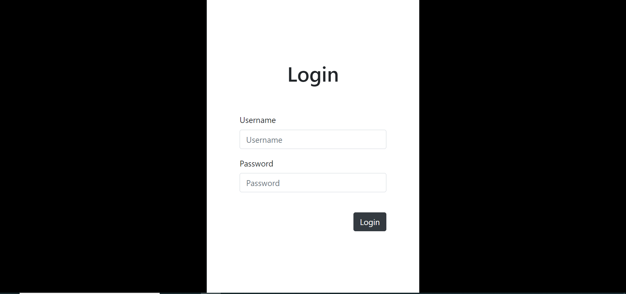

  - Search function
In this section I add search capability to the Index action method that lets the user search items by name. To
search, I will create a AccountController as below. To find the account, the system will read the letters which
contains in the username.
Next, I will create a View for this function and called it “Index”. The first thing I will create is a BeginForm. The
user will input letters to search and click the search button. To implement this functionality, there are a few
modifications that we need to make in our Index view.
Next, I will create the table to show all the information of account. Now “BeginForm” method under view
posts the input search value. Also find value show the view under table tag. When data is not find then the red
message show on the view otherwise find the value and show the view by using foreach loop under table tag. I
don't want this blank record to be displayed so I will display a meaningful message stating “Records not
found”.
In the interface, the user can view accounts list and also search for the specific account by entering username.

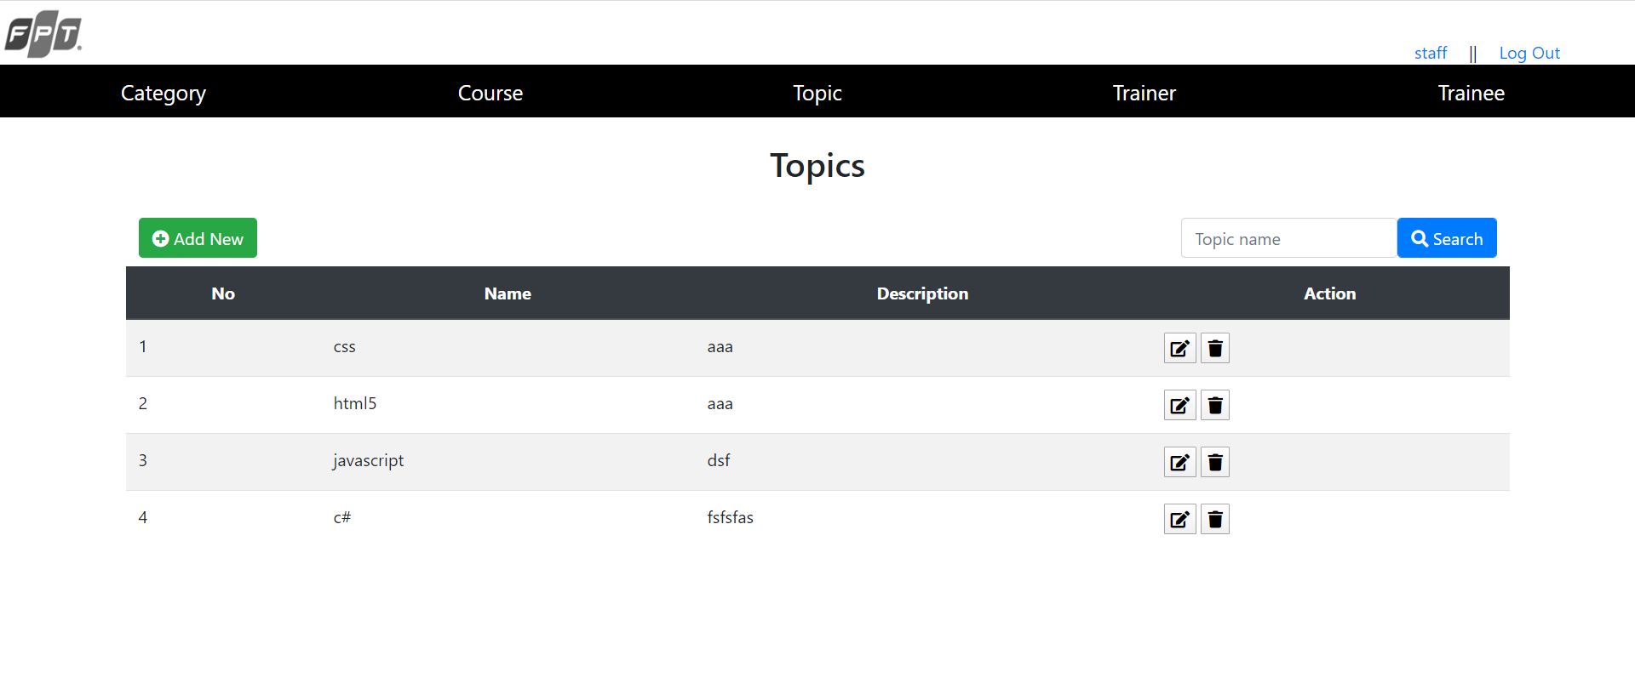
  - Add function
The first Create () method returns the corresponding View as Create.cshtml. The second Create (Bind ())
method is used to retrieve data from the client entered by the user to check and save into the database.
Now lets create a Create View for the account. In the above code, you notice that @ Html.AntiForgeryToken ()
plays the role of displaying security tokens, while @ Html.ValidationSummary (true) is used to display data
verification messages.
According to the description above, @ Html.LabelFor is used to display the name tag, @ Html.EditorFor is used
to display the input element for users to enter data, and @ Html.ValidationMessageFor is used to verify the
input. Note that if you do not define a data type for properties, this section Visual Studio allows you to enter
empty or null data.
Now the interface will look like the figure below. I can create new account by input data and click the button.

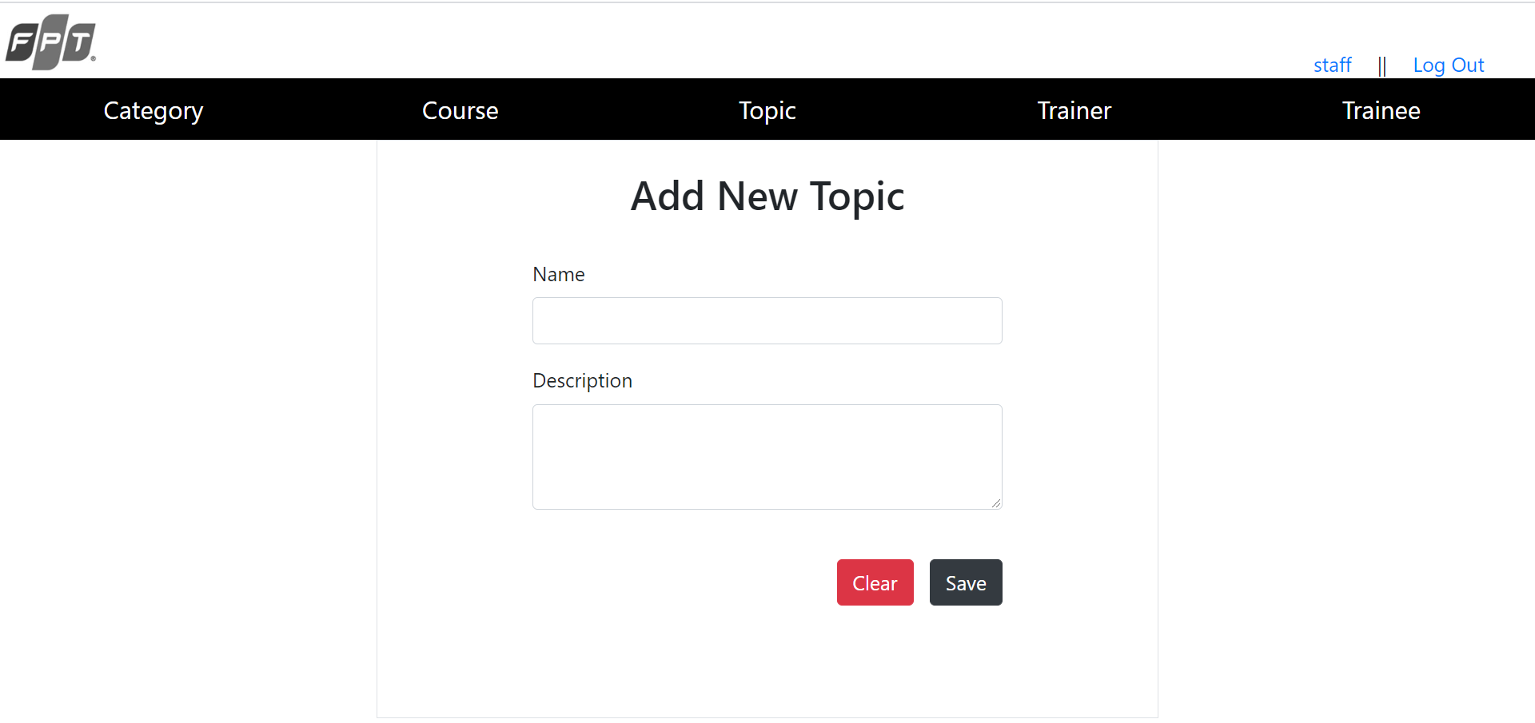
  - Edit function
In this controller, you have 2 different Edit methods according to the function overload. The Edit (int? Id)
method is used to look up the id index corresponding to the table in the database using the Entity Framework
using the Find method, and returns the results to the Edit view. The second method Edit is used to retrieve
data changed by the user and update the database information again.
In the view, we will tie all data to the model. @ Html.AntiForgeryToken () implements a token (security code)
for fraud protection in a hidden form and this token must match the Eidt method in the Account controller.
The ValidateAntiForgeryToken attribute is used to prevent a phishing request and comes with @
Html.AntiForgeryToken () in the Views \ Account \ Edit.cshtml view file with the following source code
content. Based on the above code, note the @model TutorialMVC.Models.Link clause at the top of the file to
describe the expected model for the view template as the Link.Html.LabelFor model used to display the names
of the fields attached.
After finishing coding, here is the result for the edit page.

  - Delete function
Now, we move on to do the Delete method as well as its View. As the name implies, Delete is the easiest way
to understand, because it is usually easier to break. If you have already learned about databases and have a
subtle observation of dynamic Web design, then deletion on the Web is usually deleted by the ID (or key
index) rather than by any other field.
You can see there are 2 different methods. The Delete (int? Id) method is used to delete any link with an ID
number. In this method, you can see if the input value is null or not, if not, use the Find method to find the
Link object in the database by ID, if it is then delete, otherwise return the method. HttpNotFound () method, ie
not found.
The second Delete method, DeleteConfirmed (int id), is used to confirm whether or not the user wants to
delete again. In essence, this method runs first, if the user views the delete and confirm information, the
Delete (int? Id) method will run.
In the code, I can alert to the user before deleting to display to confirm deletion. Similar to other methods, in
View Delete also uses @Html.AntiForgeryToken () to create a security token for deletion.
After finishing coding for Controller and View, the interface will be as figure below.

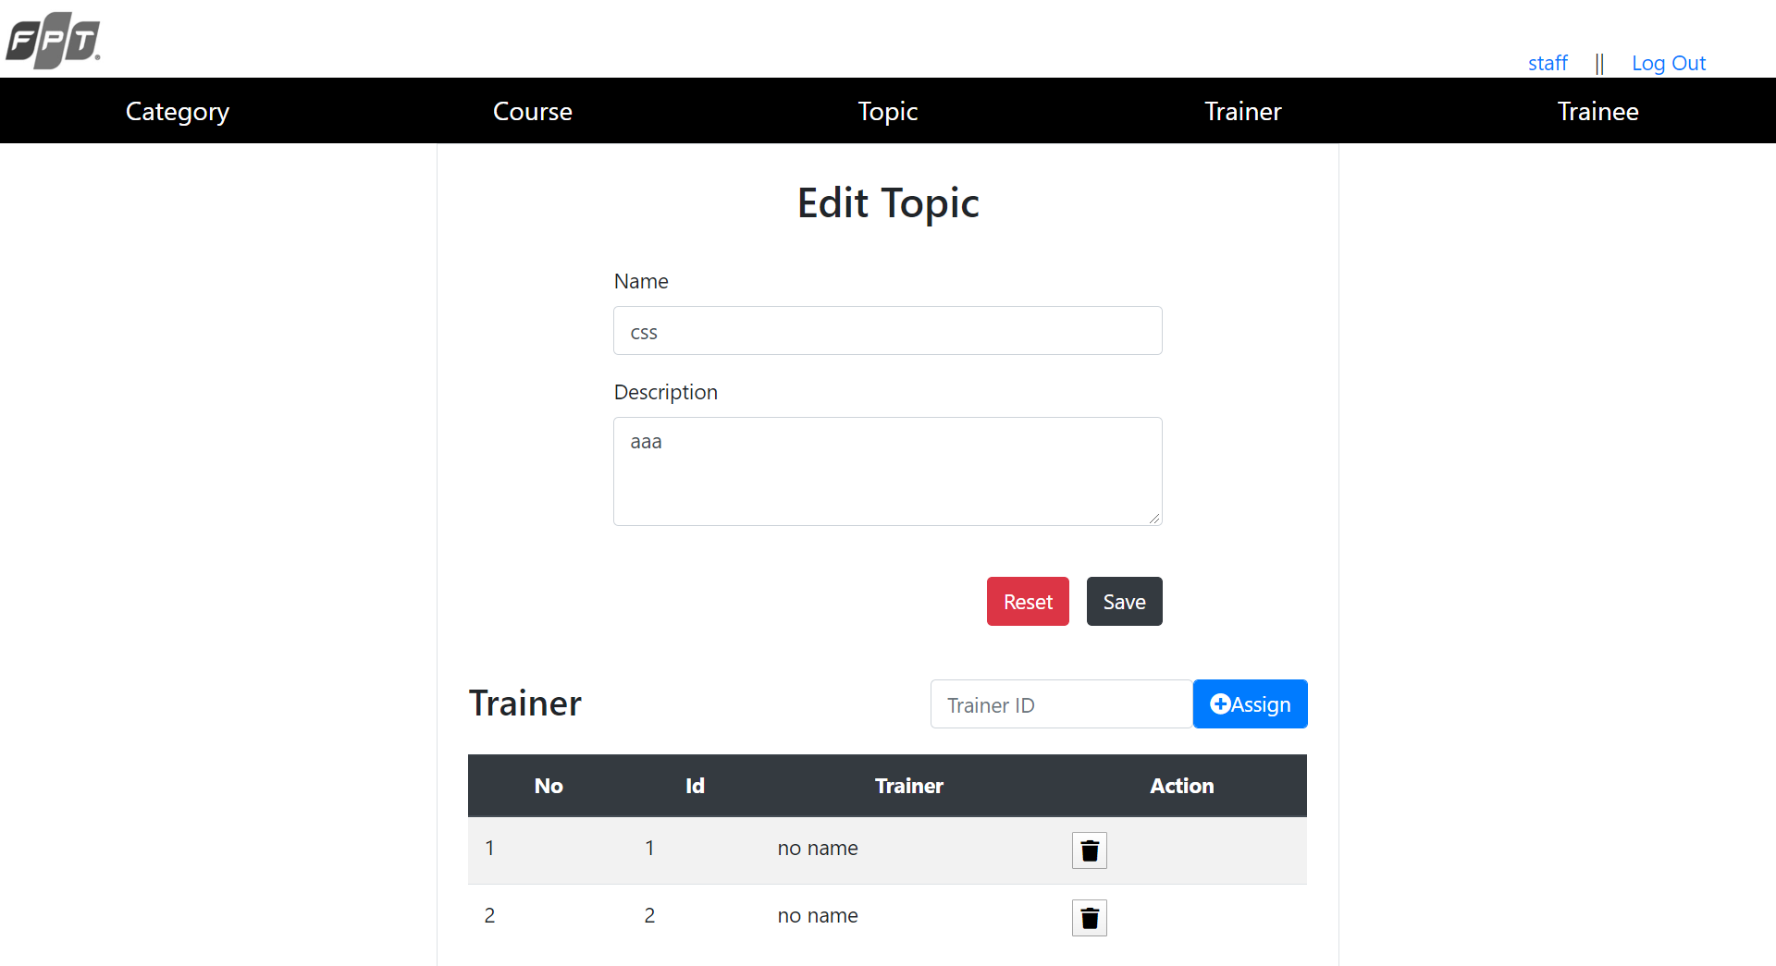
  - Assign function
To assign a trainer to a topic, I will modify in Topics controller. First of all, at HomeController I will create a
session so that when logging into the system will remember this login. After that, I will create two methods
Assign and Remove Trainer. Assign is to add a trainer into that topic, RemoveTrainer means that remove a
trainer out of the topic
Secondly, I will create a Trainer table in the edit view to show the information of the trainers who are
assigned. According to the description above, @ Html.LabelFor is used to display the name tag, @
Html.EditorFor is used to display the input element for users to enter data, and @ Html.ValidationMessageFor
is used to verify the input.
After that, I will see the interface and test the functions. As you can see from the figure below, I have assigned
two trainers into that topic.

- Review performance
  - Test plan
- Admin

- Training Staff

- Trainer

- Trainee

  - Test result
- Admin

- Training Staff

- Trainer

- Trainee

References
- Entityframeworktutorial.net. 2020. Fluent API In Entity Framework 6. [online] Available at: <https://www.entityframeworktutorial.net/code-first/fluent-api-in-code-first.aspx> [Accessed 9 May 2020].
- Entityframeworktutorial.net. 2020. Configure One-To-One Relationship In Code First Entity Framework. [online] Available at: <https://www.entityframeworktutorial.net/code-first/configure-one-to-one-relationship-in-code-first.aspx> [Accessed 9 May 2020].
- Entityframeworktutorial.net. 2020. Configure One-To-Many Relationship In Entity Framework 6. [online] Available at: <https://www.entityframeworktutorial.net/code-first/configure-one-to-many-relationship-in-code-first.aspx> [Accessed 9 May 2020].
- Entityframeworktutorial.net. 2020. Configure Many-To-Many Relationship In Code First. [online] Available at: <https://www.entityframeworktutorial.net/code-first/configure-many-to-many-relationship-in-code-first.aspx> [Accessed 9 May 2020].
- Entityframeworktutorial.net. 2020. Cascade Delete In Entity Framework 6. [online] Available at: <https://www.entityframeworktutorial.net/code-first/cascade-delete-in-code-first.aspx> [Accessed 9 May 2020].
- Mark Otto, a., 2020. Tables. [online] Getbootstrap.com. Available at: <https://getbootstrap.com/docs/4.4/content/tables/> [Accessed 10 May 2020].
- Mcleod, S., 2020. Questionnaire: : Definition, Examples, Design And Types | Simply Psychology. [online] Simplypsychology.org. Available at: <https://www.simplypsychology.org/questionnaires.html> [Accessed 10 May 2020].
- Mark Otto, a., 2020. Grid System. [online] Getbootstrap.com. Available at: <https://getbootstrap.com/docs/4.1/layout/grid/> [Accessed 10 May 2020].
- application?, H., Gaotingwe, T., Enamno, J., Woodward, J., Maccaferri, L. and Sharma, M., 2020. How To Use Sessions In An ASP.NET MVC 4 Application?. [online] Stack Overflow. Available at: <https://stackoverflow.com/questions/14138872/how-to-use-sessions-in-an-asp-net-mvc-4-application> [Accessed 10 May 2020].
- js.foundation, J., 2020. Jquery.Ajax() | Jquery API Documentation. [online] Api.jquery.com. Available at: <https://api.jquery.com/jquery.ajax/> [Accessed 10 May 2020].

